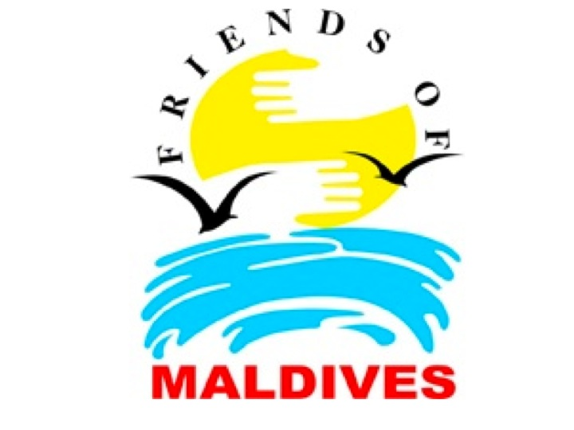

FOM Statement July 2012
Friends of Maldives (FOM) believes that a complete travel boycott to the Maldives should be a matter of the last resort.
There is ample evidence already in the public domain that the democratically elected government of the Maldives was forced to resign under duress. it is clear that the current regime’s democratic credentials have been called into doubt and the country’s credibility as a democracy can only be restored by free and fair elections. FOM feels that we should, nevertheless, allow for due process and wait to see the results of the Committee of National Inquiry (CoNI) and the conclusions reached by the Commonwealth, the EU and other stakeholders in the international community, who have played a major role in helping to promote democracy and respect for human rights in the Maldives.
FOM calls upon the current regime in the Maldives to allow the newly constituted CoNI to complete its work without any further delay, hindrance or undue influence.
Ultimately, regardless of the findings of the CoNI or other party, early free and fair elections is the goal sought by the majority of Maldivians and the international community. Provided they are free and fair, and there are no attempts at intimidation, bribery or coercion prior to the polling date, all parties should agree to respect the outcome of these elections and to work together towards restoring the democratic mandate to an elected government with a loyal opposition.
If early elections continue to be delayed by the current regime, after the CoNI issues its report and the international community has made its deliberations, then FOM believes that these would be grounds for a complete and comprehensive boycott of tourism to the Maldives, as well as for the application of further measures by the international community.
Until then, FOM supports the recommendations made by the Maldives Travel Advisory (MTA), where visitors are urged to be selective and avoid resorts with established links with the coup and the coup regime. Visitors taking these simple steps will help alleviate additional burdens on the economy while withholding funds from those involved in the suppression of human rights and democracy in the Maldives.

